## Exercise 1.16.6: Career Site: Style Special Pieces

Copy your HTML code from the previous Career Profile website exercise

### Fill in some content

Let’s fill in the last piece of information on jobinfo.html, the **Related Careers** section. You should be able to find this information from the BLS site that you used before.

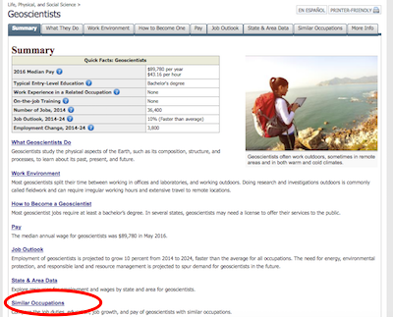

Make an unordered list that contains at least three related careers that sound interesting to you. The items in the list should be in the form

Job Title: Very short description

You should NOT copy and paste the description. Put it in your own words.

For example, a career related to a geoscientist (which is what a paleontogist is) is

Anthropologists and Archeologists: study ancient remains of people to learn about the development of cultures

### Add some spans

Once you’ve made the list, put each of the job titles in a <span></span> with the class job-title, like this:

<span class="job-title"> Anthropologists and Archeologists: </span> study ancient remains of people to learn about the development of cultures

### Add the styles

Finally, in style.css, give job-title the following properties:

* bold font-weight
* maroon color

Screenshot attribution:

Bureau of Labor Statistics, U.S. Department of Labor, Occupational Outlook Handbook, 2016-17 Edition, Geoscientists, on the Internet at <https://www.bls.gov/ooh/life-physical-and-social-science/geoscientists.htm> (visited July 10, 2017).